Numerical Methods

**Report**

Date of the exercise: **11/04/2019**

Exercise: **Integration**

Group: 2, Team:

Subsection (names):

1. Mateusz Nowotnik

2. Dawid Tomala

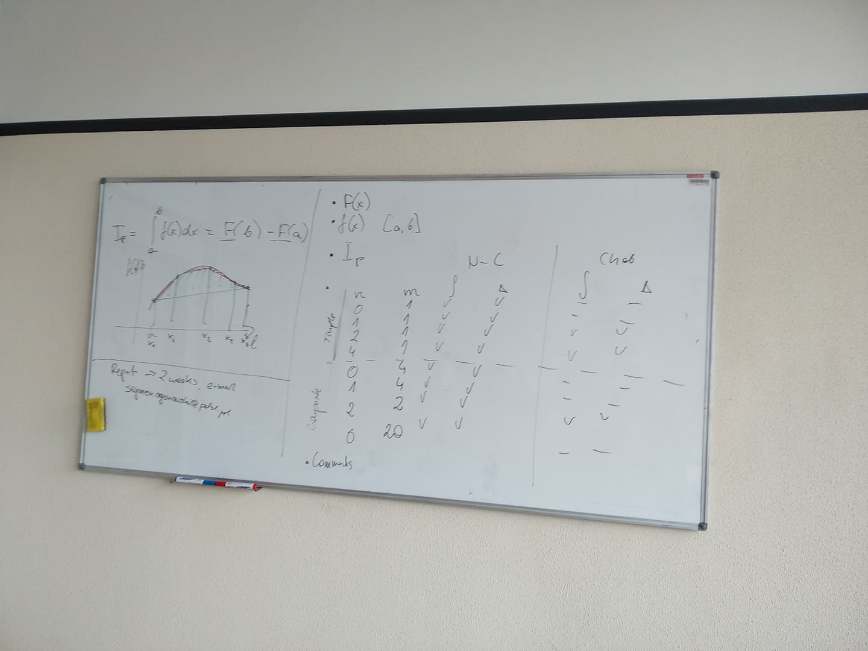

1. F(x) = 20*x*sin((x+10)/10)+200*cos((x+10)/10)-((2*cos((5*x)/2))/(5))

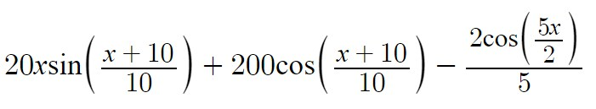

2. f(x) = sin(2.5*x)+2*x*cos(0.1*x+1), interval [0, 4]

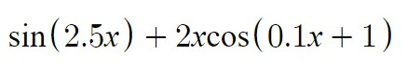

3. F(b) – F(a) = 5.5046

4. Ploty

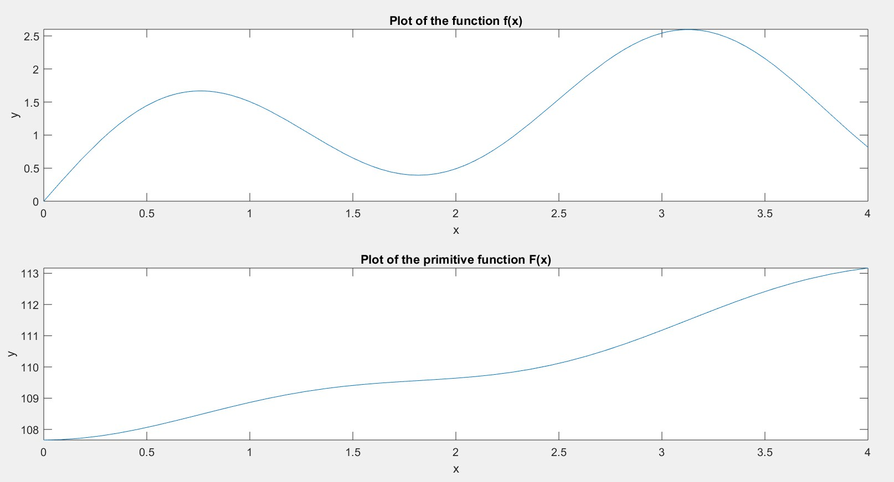

5. Kod z matlaba

syms x

a = 0;

b = 4;

f = @(x)sin(2.5.*x)+2.*x.*cos((0.1.*x)+1);

F = @(x)20.*x.*sin((x+10)/10)+200.*cos((x+10)/10)-((2.*cos((5.*x)/2))/(5));

subplot(2,1,1)

fplot(f, [a b])

xlabel('x')

ylabel('y')

title('Plot of the function f(x)')

subplot(2,1,2)

fplot(F, [a b])

xlabel('x')

ylabel('y')

title('Plot of the primitive function F(x)')

PreciseIntegral = feval(F, b) - feval(F, a)

6. kod z main.cpp (można wkleic do: <http://www.planetb.ca/syntax-highlight-word>)

7. Output z consoli

8. Summary